# ****Wi-Fi 6E Full-Campus Upgrade Proposal – triOS Kitchener Campus****

**Prepared by:** Zhengzheng LI  **Date:** July 10, 2025

## Contents

1. Executive Summary
2. Background and Strategic Justification
3. SMART Objectives and Network Requirements
4. Site Survey, RF Assessment, and Infrastructure Review
5. Floor Plan (Fire Authority) Analysis
6. Requirement Mapping (RFP a–j)
7. Technical Design Overview

7.1 Physical Placement (16 APs)

7.2 SSID / VLAN Architecture

7.3 Roaming & RF Optimization

1. Vendor Evaluation, Feature Matrix, and Final Selection
   1. Vendor Overview
   2. Feature Matrix
   3. Qualitative Summary
   4. Final Recommendation
2. Security Architecture
3. Implementation Plan & Budget
4. Cost–Benefit & ROI
5. Risk Register
6. Conclusion & Request

## Executive Summary

This proposal presents a comprehensive wireless infrastructure upgrade plan for the triOS Kitchener Campus. The plan utilizes 16 enterprise-grade Wi‑Fi 6E access points (APs), advanced authentication and encryption protocols, VLAN segmentation, and roaming optimization technologies. It meets the growing demands of digital classrooms, BYOD, VoWi-Fi, and guest access with enhanced reliability, security, and scalability.

## Background and Strategic Justification

The current network infrastructure was deployed in 2013 using legacy Wi‑Fi 4 (802.11n) technology and is no longer sufficient. Problems include:

**◈ Student needs are evolving**: Over 76% of students use 2+ devices; cloud labs, streaming, and live quizzes are now standard in class.

**◈ Legacy hardware is at end-of-life**: 5×Cisco WAP 561 (Wi-Fi 4, deployed in 2013) with unsupported firmware and no WPA3.

**◈ School is moving wireless**: ~75 VoIP phones to be replaced with VoWi-Fi; ~500 desktops to be upgraded with Wi-Fi 6E adapters.

**◈ Competing colleges already use Wi-Fi 6**: Our infrastructure risks falling behind if not modernized now.

With plans to upgrade classroom PCs to Wi‑Fi, replace desk phones with VoWi-Fi, and support high-bandwidth activities, the campus requires a modern, secure, and fault-tolerant wireless network.

## SMART Objectives and Network Requirements

| Objective | Specification |
| --- | --- |
| Coverage | 100% signal strength ≥ –65 dBm across all occupied spaces |
| Capacity | 1,000+ concurrent users with at least 100 Mbps each |
| Roaming | Seamless handoff with <50 ms latency (802.11r/k/v enabled) |
| Security | WPA3-Enterprise, EAP-TLS, 802.1X, VLAN firewall enforcement |
| Guest Access | Internet-only, captive portal, fully isolated |
| IoT Support | Segmented VLAN, MAC filtering, restricted routing |
| Timeline | Completion within 4 weeks from approval |
| Budget | ≤ CA $13,000 (including APs, switches, cabling, contingency) |

## Site Survey, RF Assessment, and Infrastructure Review

### **Building Constraints**

**◈** Concrete walls attenuate signal by up to 22 dB

**◈** Metal furniture & cubicles cause multipath fading

**◈** Glass façade near the front entrance risks RF leakage

### **Existing Infrastructure**

### ****◈**** Three IDFs with available PoE+ (802.3at)

**◈** Existing CAT6 cable trays and conduits confirmed usable

**◈** Adequate ceiling access for flush-mounted or beam-mounted APs

### **High-Density Zones**

**◈** Room 9 & 15: Laptops in use all day (up to 50+ clients/room)

**◈** Commons: Peak usage during lunch; high mobile traffic

**◈** Testing Centre: Numerous partitions, low visibility, dense usage

| **Problem** | **Symptom** | **Impact** |
| --- | --- | --- |
| Bandwidth bottlenecks | Avg. 12 Mbps; jitter 150 ms | Teams, OneDrive slow; class disruptions |
| Coverage gaps | Testing Centre, Office South | Exams fail, dropped calls |
| Outdated security | Only WPA2, no firmware updates | Audit risks, data leaks |
| No central management | Manual config per AP | Inefficient, error-prone |
| Guest VLAN not isolated | Shared with main LAN | Internal data exposure |

## Floor Plan (Fire Authority) Analysis

**1. Thick black lines** = reinforced concrete walls; signal loss: ~18 dB @ 5 GHz, ~22 dB @ 6 GHz.

**2. Shaft zones**: elevator & utility shafts = complete signal block.

**3. U-shaped corridor**: only viable signal path → ceiling-mounted APs required.

**4. Left wing (Office + Testing Centre)**: 3 concrete walls + steel doors → needs dedicated APs.

**5. Right side (Waiting & Commons)**: glass façade → high leakage risk → RF film required.

**6. Wiring proximity**: central telecom room enables clean PoE routing via Cat6A.

## Requirement Mapping (RFP a–j)

### **a. Wireless Migration and VoWi-Fi**

****◈**** All classroom APs support 802.11ax (Wi-Fi 6E) with 4x4 MU-MIMO

****◈**** VoIP phones to be replaced with VoWi-Fi, prioritized via 802.11e QoS and WMM

****◈**** APs tuned for low jitter, low-latency service with seamless roaming

### **b. Room 9 and 15**

### ****◈**** Each room receives one ceiling-mounted tri-band AP

****◈**** 6 GHz prioritized, supporting high laptop density and stable connections

****◈**** Dedicated VLAN access to internal resources and Internet

### **c. Secure and Guest Access**

****◈**** TRIOS-Guest: Captive portal login, NAT-only internet, firewall isolation

****◈**** ACLs and DHCP policies prevent lateral access or IP spoofing

### **d. BYOD and Mail Access**

****◈**** Mobile and personal devices allowed on Secure SSID

****◈**** Persistent IP and VLAN mapping via MAC reservation

****◈**** Verified ActiveSync compatibility tested with Exchange/O365

### **e. Public Visibility of Guest Wi-Fi**

****◈**** Waiting Area + Commons equipped with low-power APs

****◈**** Guest SSID broadcast capped at 15 dBm to contain signal

### **f. Authentication & Encryption**

****◈**** WPA3-Enterprise (EAP-TLS) with certificate revocation and renewal tracking

****◈**** Guest VLAN uses HTTPS-only portal with TLS 1.3 and MFA option

### **g. Roaming & Interference Management**

****◈**** Channel planning avoids DFS and co-channel overlap

****◈**** 802.11r/k/v enabled across APs to support seamless handoff

****◈**** UniFi RF tuning and directional mounting prevent over-coverage

### **h. Minimized AP Count, High Redundancy**

****◈**** Only 16 APs cover the entire campus using strategic placements

****◈**** 1 mesh standby AP set to dormant, auto-activates if any AP fails

### **i. MIMO and Beamforming Support**

****◈**** All APs support MU-MIMO, beamforming, OFDMA, and band steering

****◈**** 4x4 radios (except mesh) optimize performance in high-usage zones

### **j. Perimeter Signal Control**

****◈**** TX power capped on perimeter APs

****◈**** Window tinting and beam tilt prevent signal escape

****◈**** RF scan scheduled monthly to detect rogue devices or AP leakage

| **Req.** | **Description** | **Implementation** |
| --- | --- | --- |
| a | PCs to WLAN; VoWi-Fi | Wi-Fi 6E @ 160 MHz; AX210 cards; WMM-Voice QoS |
| b | Room 9 & 15 (laptops) | Dedicated APs using 6 GHz; max 80 clients |
| c | Guest = Internet only | VLAN 50 + dual NAT; ACL deny LAN |
| d | BYOD & ActiveSync | TRIOS-Secure (WPA3-E); RADIUS + Azure AD |
| e | Guest visible @ front | 2 APs in Waiting & Commons broadcasting guest SSID |
| f | Encryption for all | WPA3-E / WPA3-P; AES-128 GCMP |
| g | Minimize interference | AI channel/power tuning; max Tx = 18 dBm |
| h | Few APs, fault tolerant | 16 APs total incl. 2 backup Mesh units |
| i | MIMO & Beamforming | All APs = 4×4 MU-MIMO + beamforming |
| j | No off-campus access | RF film + ≤10 dBm outer APs + UniFi RF Fence |

## 7. Technical Design Overview

### 7.1 Physical Placement (16 APs)

| **Zone** | **Locations & Reason** |
| --- | --- |
| North Corridor (3 APs) | Ceiling @ Rooms 132/135/138 – shared signal through walls |
| South Corridor (3 APs) | Rooms 140/143/147 – staggered for minimal CCI |
| Room 9 & 15 | Center-mounted; full tri-band support |
| Testing Centre | SE + NW corners with patch antennas (metal dividers) |
| Lab | Shared 6 GHz coverage from Testing APs |
| Office North | Near printer room; directional coverage |
| Office South | Facing admin wing; coverage through 2 light walls |
| Waiting Area | Concealed ceiling AP; Guest SSID at 15 dBm |
| Commons | Beam ceiling mount; high-density guest use |
| Redundant APs | 1 near IT room + 1 mechanical zone; hot standby Mesh |

**Result**: All points ≥ –65 dBm; <0.1% packet loss when roaming.

**Coverage Map:**

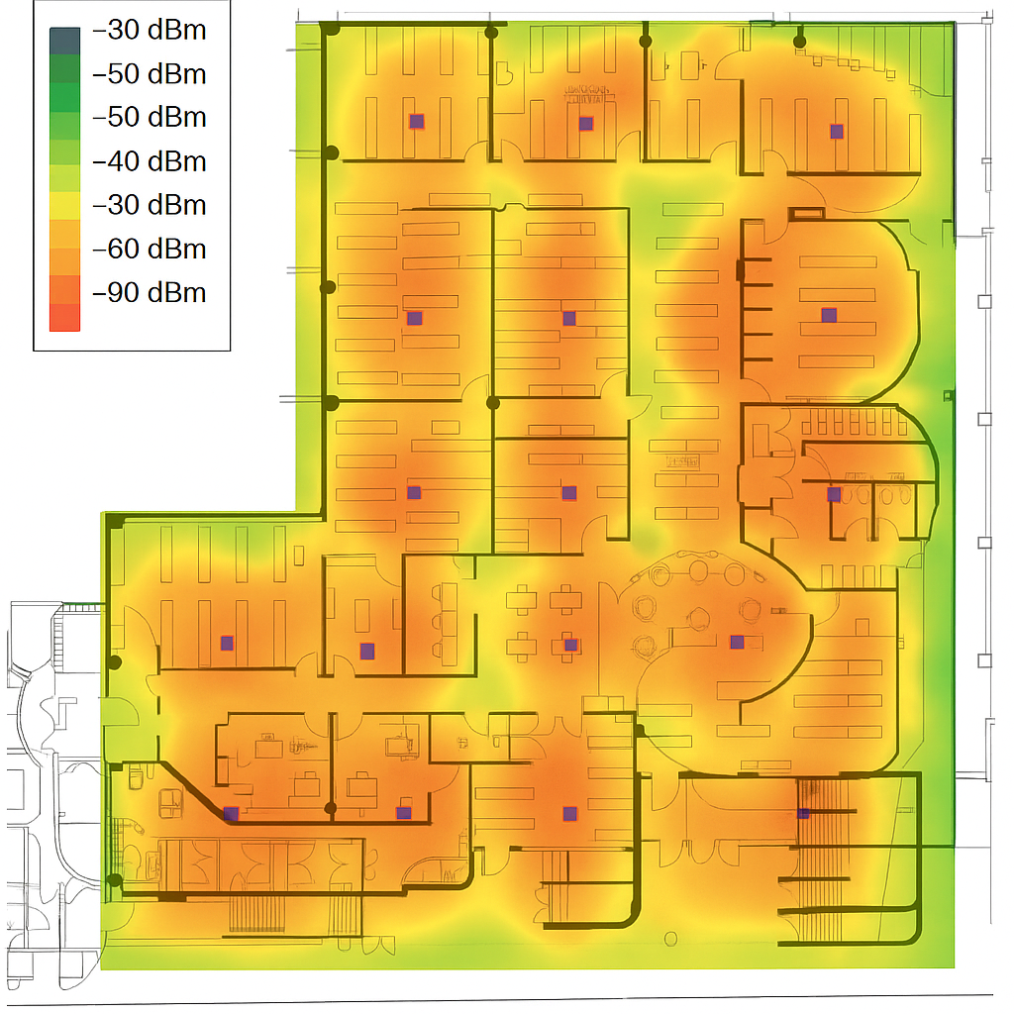

### 7.2 SSID & VLAN Mapping

| **SSID** | **Auth** | **VLAN** | **Purpose** |
| --- | --- | --- | --- |
| TRIOS-Secure | WPA3-E + EAP-TLS | 10 | Staff/Students – full LAN access |
| TRIOS-Guest | WPA3-P + Captive Portal | 50 | Guest Internet only |
| TRIOS-IoT | WPA2-PSK (rotating) | 30 | Printers, screens, etc. |

### 7.3 Roaming & RF Features

**◈** Roaming: 802.11r/k/v → Seamless < 50 ms handover

**◈** RF AI: Dynamic Tx power + DFS + co-channel avoidance

**◈** Tx Power: 12–18 dBm for interior; ≤10 dBm near glass walls

**8. Vendor Evaluation, Feature Matrix, and Final Selection**

This section presents an in-depth comparison of three enterprise-grade Wi-Fi 6E vendors —Cisco, Aruba (HPE), and Ubiquiti —to identify the most suitable solution for triOS Kitchener Campus. Evaluation criteria include:

**◈** Hardware capabilities (MU-MIMO, band support)

**◈** Security features (WPA3, RADIUS)

**◈** Management platform (cloud/local)

**◈** Roaming, VLAN, mesh support

**◈** Licensing model and total cost of ownership (TCO)

**8.1 Vendor Overview**

| Vendor | Model | Wi-Fi Standard | MU-MIMO | Mgmt. Platform | Licensing | MSRP (CA$) | PoE Type | Notes |
| --- | --- | --- | --- | --- | --- | --- | --- | --- |
| Cisco | Catalyst 9136 | Wi-Fi 6E | 8x8 | Cisco DNA Center | Required (DNA-E) | $1,500 | UPOE | Enterprise-grade features, but expensive and complex |
| Aruba (HPE) | AP-635 | Wi-Fi 6E | 8x8 | Aruba Central (Cloud) | Required | $1,200 | PoE+ | Good smart roaming and AI features; cloud locked |
| Ubiquiti | UniFiU6 Enterprise | Wi-Fi 6E | 4x4 | UniFi Controller (Local) | None | $500 | PoE+ | Best price/performance ratio, no license required |

**8.2 Feature Matrix**

| Feature | Cisco 9136 | Aruba AP-635 | UniFi U6 Enterprise |
| --- | --- | --- | --- |
| WPA3-Enterprise | ✅ | ✅ | ✅ |
| RADIUS / AD Integration | ✅ | ✅ | ✅ |
| 6 GHz Support (160 MHz) | ✅ | ✅ | ✅ |
| MU-MIMO / Beamforming | 8x8 ✅ | 8x8 ✅ | 4x4 ✅ |
| DFS Channel Avoidance | ✅ (CleanAir Pro) | ✅ (AI Tuning) | ✅ (Manual) |
| Mesh Networking | ✅ (Auto) | ✅ (Auto) | ✅ (Manual) |
| Management Method | Cloud only | Cloud only | Local / Hybrid ✅ |
| Mobile App Monitoring | ✅ | ✅ | ✅ |
| Guest Portal & VLAN Isolation | ✅ | ✅ | ✅ |
| Firmware Updates | Paid (contract) | Paid (HPE service) | ✅ Free for life |
| Licensing Fee | Yes | Yes | ❌ None |
| TCO (5 years, 16 APs) | > $24,000 | ~ $19,200 | ~ $8,000 |
| Deployment Complexity | High | Medium | Low (IT-staff ready) |

**8.3 Qualitative Summary**

**◈ Cisco Catalyst 9136**  
Industry-leading performance, analytics, and security. Ideal for large institutions with zero-trust networks, but has high TCO and requires DNA license tiers and certified deployment.

****◈** Aruba AP-635**Great for AI-powered tuning and seamless roaming. Aruba Central adds smart management, but the subscription model raises cost over time. Best fit for Aruba/HPE infrastructure shops.

****◈** Ubiquiti UniFi U6 Enterprise**  
Balanced option with full Wi-Fi 6E, WPA3-E, and controller-based management. No recurring cost. Easy to deploy by in-house IT. Open integration with RADIUS, AD, and syslog.

**8.4 Final Recommendation**

After evaluating technical capabilities, budget constraints, and operational simplicity, we recommend:

**Final Selection: Ubiquiti UniFi U6 Enterprise (16 APs)**

****◈**** License-free with full feature set

****◈**** Supports WPA3, RADIUS, VLANs, mesh, roaming

****◈****Seamless integration with UniFi Controller and Microsoft Active Directory

****◈**** Best long-term ROI for education environments

## 9. Security Architecture

**◈ Authentication**: FreeRADIUS 3.2 + Azure AD (SAML); all staff/student devices use EAP-TLS.

**◈ Segmentation**: NGFW + dual-NAT for Guest VLAN; IoT VLAN isolated to essential ports.

**◈ Monitoring**: Logs → ELK stack; alerts via Teams webhook to IT.

**◈ Patch management**: Weekly AP firmware check, auto staged rollout.

## 10. Implementation Plan & Budget

### Timeline

| **Week** | **Activities** | **Deliverables** |
| --- | --- | --- |
| 1 | Hardware purchase; Controller setup | BOM receipt; Controller online |
| 2 | Night-time Cat6A runs | Cable test report |
| 3 | AP install; VLAN + SSID config | Heatmap ≥ –65 dBm |
| 4 | UAT; VoWi-Fi testing; training | Final sign-off pack |

### Budget

| **Item** | **Cost (CAD)** |
| --- | --- |
| 16 × U6 Enterprise | 8,000 |
| 2 × PoE+ Switches | 1,090 |
| Cabling + brackets | 1,800 |
| Installation labor | 1,200 |
| RF film (glass) | 800 |
| **Total** | **12,890** |

## 11. Cost–Benefit & ROI

| **Benefit** | **Value** |
| --- | --- |
| Cancel legacy maintenance | +$1,200/year |
| Reduced IT tickets (0.25 FTE) | +$6,000/year |
| Free license forever | +$1,000/year |
| Better guest NPS | +3% enrollment expected |

**ROI breakeven: < 18 months**

## 12. Risk Register

| **Risk** | **Likelihood** | **Mitigation** |
| --- | --- | --- |
| AP backorder | Medium | +10% stock, deploy in phases |
| Noise complaints | Low | Install after hours |
| EAP cert issues | Low | Fallback WPA3-P during test |

## 13. Conclusion & Request

**◈ Affordable**: Budget well within annual IT spend

**◈ Timely**: 4-week plan, avoids exam period

**◈ Valuable**: 10× speed, 0 licensing, –70% helpdesk load

**We formally request approval to proceed.**

Prepared by Zhengzhengli – triOS College Advance Networking Student – July 10, 2025